TL/BDG/2022-09-26/016028
TL/BPL/2025-10-10/071702 UDYAM-OD-04-0039313

ଆମ ଅଂଚଳ ର ମାସିକ ବିଜ୍ଞାପନ ପୁସ୍ତିକା
ପ୍ରଚାର
PRACHAR
PHYGITAL PUBLICITY
7077011733 / 9178898844
PRACHARBBSR1@GMAIL.COM

FREE DISTRIBUTION
ମାଗଣା ବଣ୍ଟନ

..

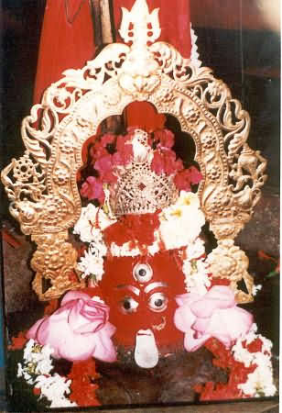
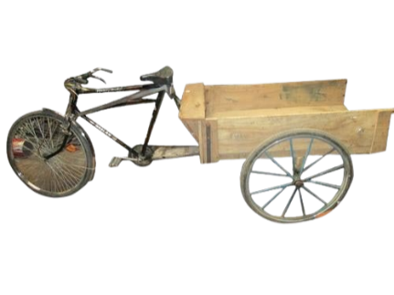
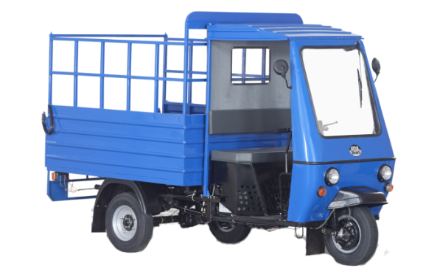
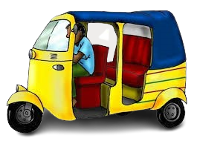

“ପ୍ରଚାର” ରେ ବିଜ୍ଞାପନ ଓ ବାର୍ତା ସେବା ପାଇଁ ସମ୍ପର୍କ କରନ୍ତୁ













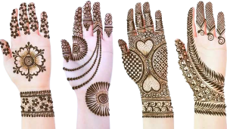
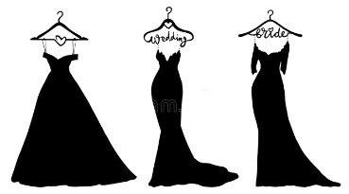

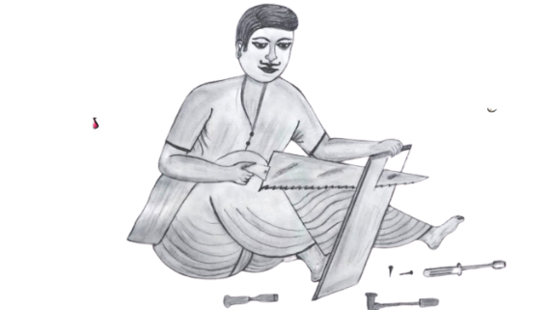



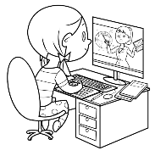
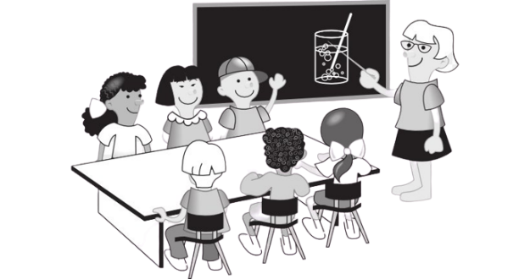


ବ୍ୟବସାୟ ଓ ସେବା ର ବିଜ୍ଞାପନ ଦିଅନ୍ତୁ I
ବ୍ୟବସାୟ ର ନୁଆଁ ଅଫର ଓ ଖବର ଜଣାନ୍ତୁ I
ପର୍ବ ପର୍ବାଣି ର ଶୁଭେଚ୍ଛା ଜଣାନ୍ତୁ I
ଜନ୍ମଦିନ / ବିବାହ ବାର୍ଷିକୀ ର ଶୁଭେଚ୍ଛା ଜଣାନ୍ତୁ I




7077011733 / 9178898844
PRACHARBBSR1@GMAIL.COM



PRACHAR
PHYGITAL PUBLICITY

NAME | DETAILS | 1ST EDITION Rs. | SCHEME  FOR 3 EDITION
P1 | B&W MINI-QUARTER | 550 | 1500
P2 | B&W QUARTER | 1030 | 3000
P3 | B&W HALF PAGE | 2050 | 6000
P4 | B&W FULL PAGE | 4100 | 12000
P5 | COLOUR FULL PAGE | 6000 | 15000

- All advertisements, logos, photos, material, claims given, in the messages are solely from the Advertisers on their free will.
- Cutoff date for all advertisement is 18TH of every month.
- Charges of display advertisement should be in all digital mode, Phone Pay, Cash
- The right to acceptance of matter is reserved with us.
- Any dispute subject to Odisha Jurisdiction only.
- For more detail call us / mail us (7077011733 / 9178898844).

7077011733 / 9178898844
PRACHARBBSR1@GMAIL.COM

PRACHAR Phyzital Pulicity It’s a Unit Of Saroswati Khabar, PRGI Registration No – ORORI/25/A3295
Chief Editor – Ashutosh Mahalik Plot No. - ……………….., BJB Nagar, Bhubaneswar, Contact No – 7978943757, Email Id – asutoshamahalik@gmail.com
Published & Owned By – Purusottam Sahu, BJB Nagar, Bhubaneswar, Contact No – 9178898844, Email Id – pracharbbsr1@gmail.com
Printed at Chandan Printers, At-Plot No-3, Gopabandhu Chhak, Unit-3, Bhubaneswar, Khordha, Pin - 751003

